Write a C++ program to investigate data types, memory allocation and pointers.

Declare a type double variable named a and assign it a value.
Declare a double pointer named pa and assign the pointer the address of the double variable named a.
Declare an array named b that will contain four type double values and assign values to the array elements.
Declare a double pointer named pb and assign it the first address of the double array named b.
Declare a double pointer named pc and use the keyword new to associate the pointer with an unnamed double variable.
Assign a value to the unnamed variable using the pointer pc.
Declare a double pointer named pd and use the keyword new to associate the pointer with an array that will hold four values. Assign values to the array elements.

Create a Memory Map that will display the name, address and data for each memory location.

Input
// ECE 2305 - Tutorial 23

#include <iostream>
#include <iomanip>

using namespace std;

int main() {
double a = 3.1416;
double* pa = &a;

double b[4] = { 1.1, 2.2, 3.3, 4.4 };
double* pb = b;

double* pc = new double;
*pc = 5.5;

double* pd = new double[4];
pd[0] = 6.6; pd[1] = 7.7; pd[2] = 8.8; pd[3] = 9.9;

cout << left << setw(15) << "Variable" << setw(20) << "Address" << "Value" << endl;
cout << endl;
cout << setw(15) << "a" << setw(20) << &a << a << endl;
cout << setw(15) << "pa" << setw(20) << &pa << pa << endl;

for (int i = 0; i < 4; i++) {
cout << "b[" << i << "]" << setw(12) << "" << setw(20) << &b[i] << b[i] << endl;
}
cout << setw(15) << "pb" << setw(20) << &pb << pb << endl;

cout << setw(15) << "pc" << setw(20) << &pc << pc << endl;
cout << setw(15) << "*pc" << setw(20) << pc << *pc << endl;

for (int i = 0; i < 4; i++) {
cout << "pd[" << i << "]" << setw(12) << "" << setw(20) << &pd[i] << pd[i] << endl;
}
cout << setw(15) << "pd" << setw(20) << &pd << pd << endl;

delete pc;
delete[] pd;

system("pause");
return 0;
}
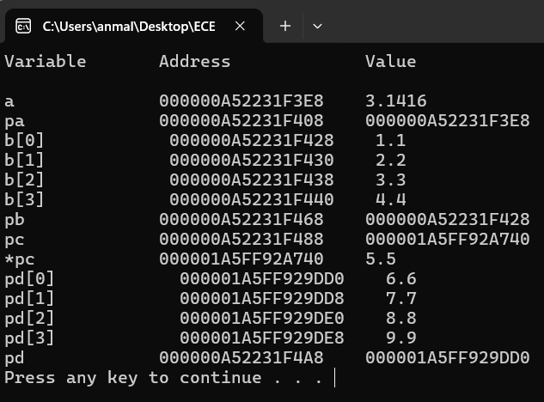
Output

